Course code :380CSS-3 Main Project

Student Name: ------------------------------------------------

Student ID: --------------------------

‏1444

(1) The E/R model for your database design together with reasonable assumption(s) made,

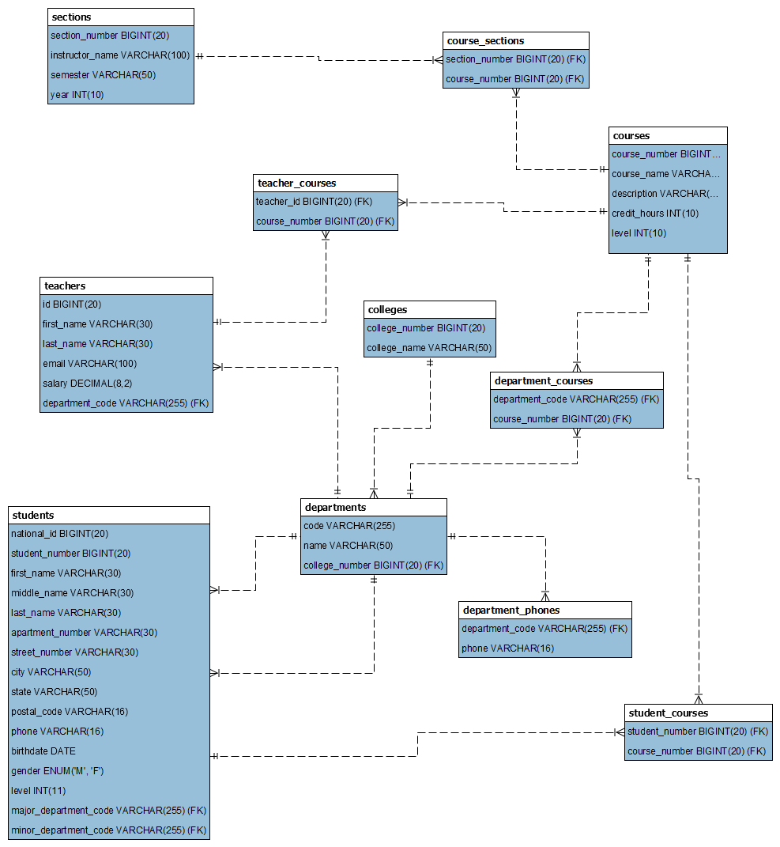

(2) List of all schemas and their attributes with appropriate data type. Also, identify the primary key for each schema together with the relationship between different schemas.

This is the SQL code to create several tables in a relational database.

The tables are:

1. **colleges**: contains information about colleges, including **college_number** (primary key), and **college_name**.
2. **courses**: contains information about courses, including **course_number** (primary key), **course_name**, **description**, **credit_hours**, and **level**.
3. **course_sections**: contains information about sections of courses, including **section_number** (primary key), and **course_number**.
4. **departments**: contains information about departments, including **code** (primary key), **name**, and **college_number**.
5. **department_courses**: contains information about courses associated with departments, including **department_code** (primary key), and **course_number**.
6. **department_phones**: contains information about department phones, including **department_code** (primary key), and **phone**.
7. **sections**: contains information about sections, including **section_number** (primary key), **instructor_name**, **semester**, and **year**.
8. **students**: contains information about students, including **student_number** (primary key), **national_id**, **first_name**, **middle_name**, **last_name**, **apartment_number**, **street_number**, **city**, **state**, **postal_code**, **phone**, **birthdate**, **gender**, **level**, **major_department_code**, and **minor_department_code**.
9. **student_courses**: contains information about courses taken by students, including **student_number** (primary key), and **course_number**.
10. **teachers**: contains information about teachers, including **id** (primary key), **first_name**, **last_name**, **email**, **salary**, and **department_code**.
11. **teacher_cources**: contains information about teachers cources, It has two columns: **teacher_id**, which is a foreign key referencing the **teachers** table's **id** column, and **course_number**, which is a foreign key referencing the **courses** table's **course_number** column

Note: In each table, fields with **NOT NULL** constraint must have a value in every row, while fields with **DEFAULT NULL** constraint can be left blank.

(3) The print out of tuples in each table, the SQL queries and the output of your queries against your database.

# The print out of tuples in each table

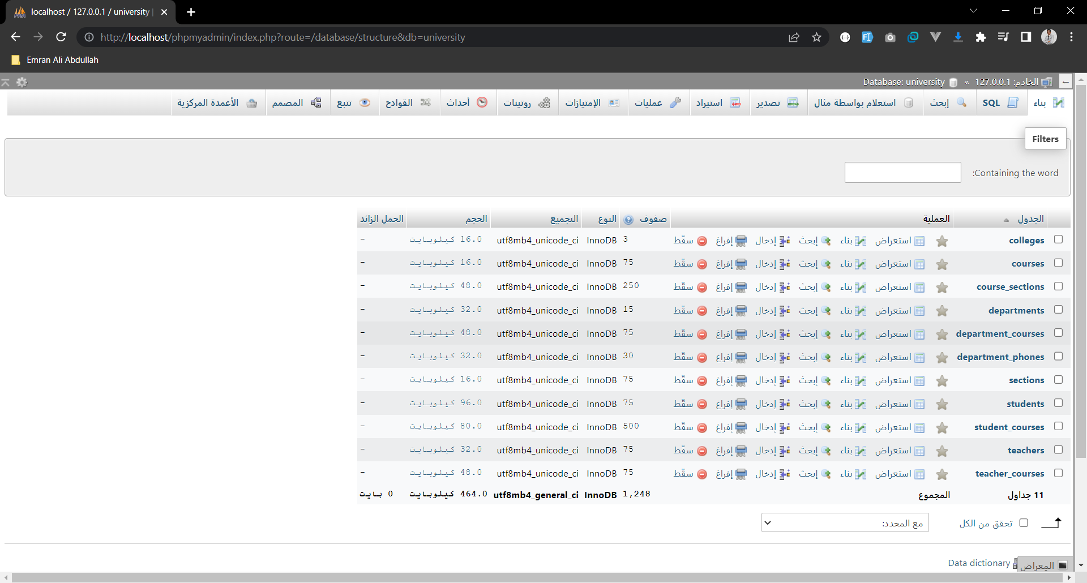

#1 Colleges

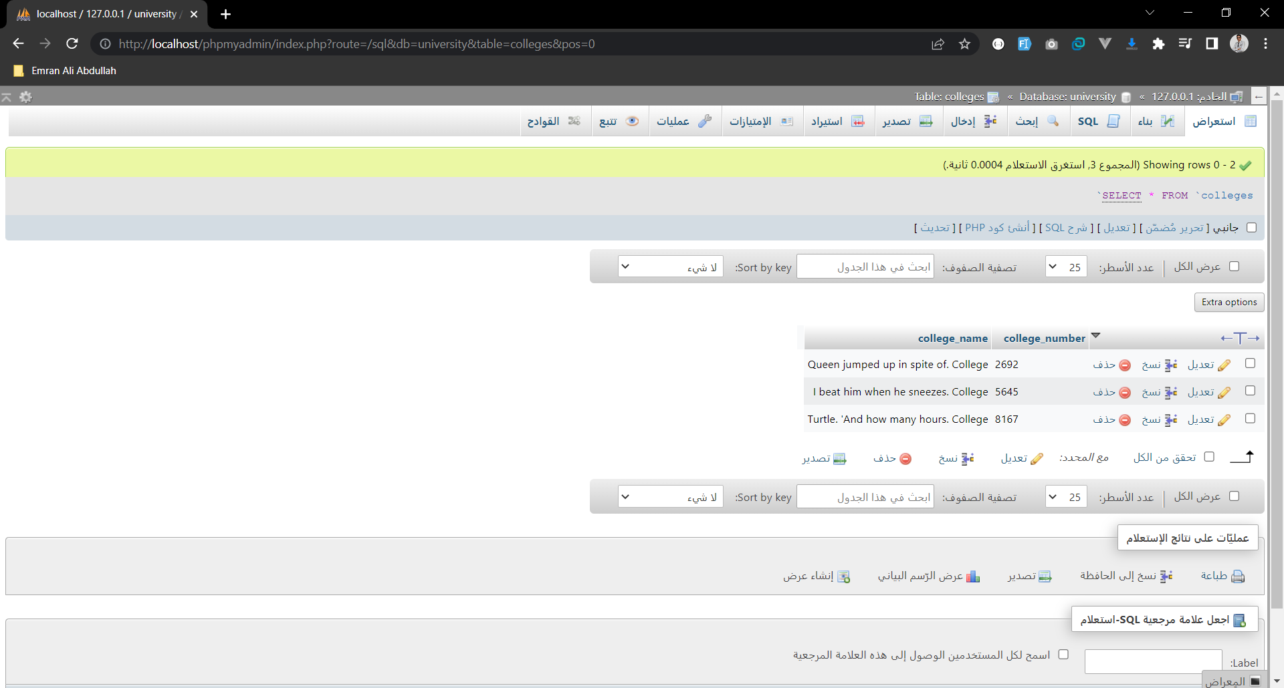

#2 Courses

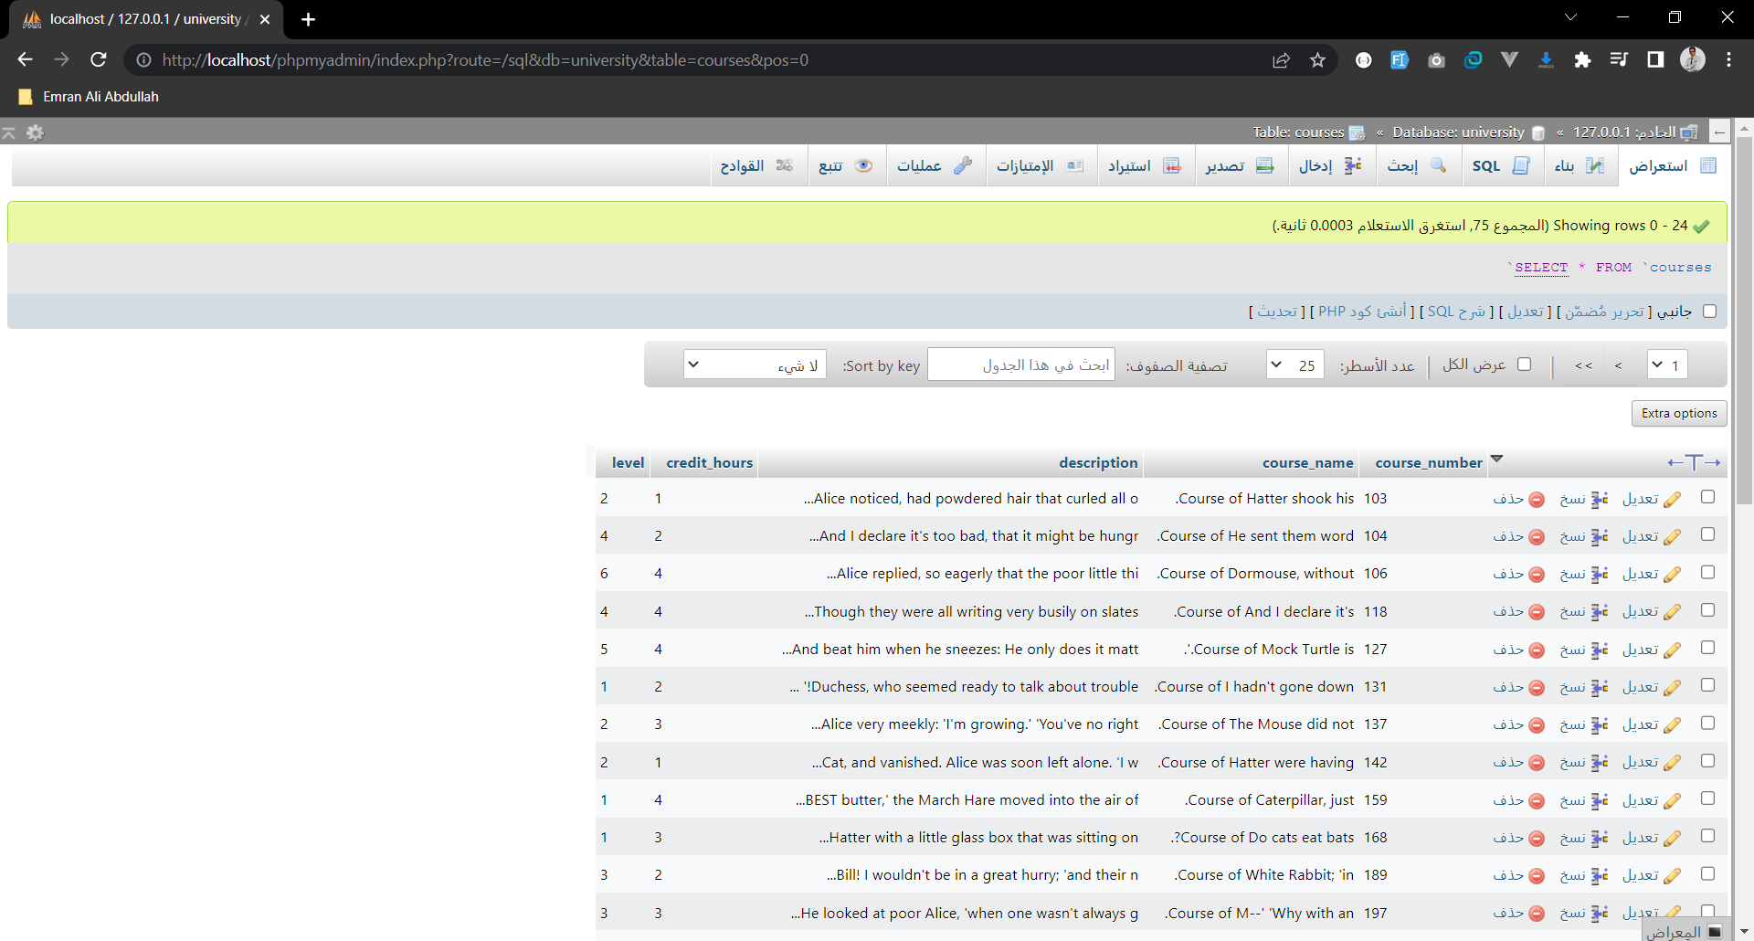

#3 Course Sections

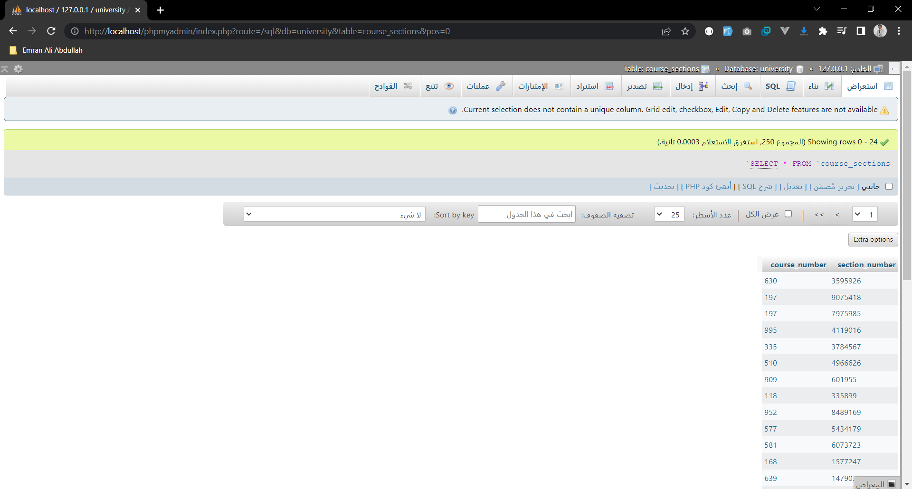

#4 Departments

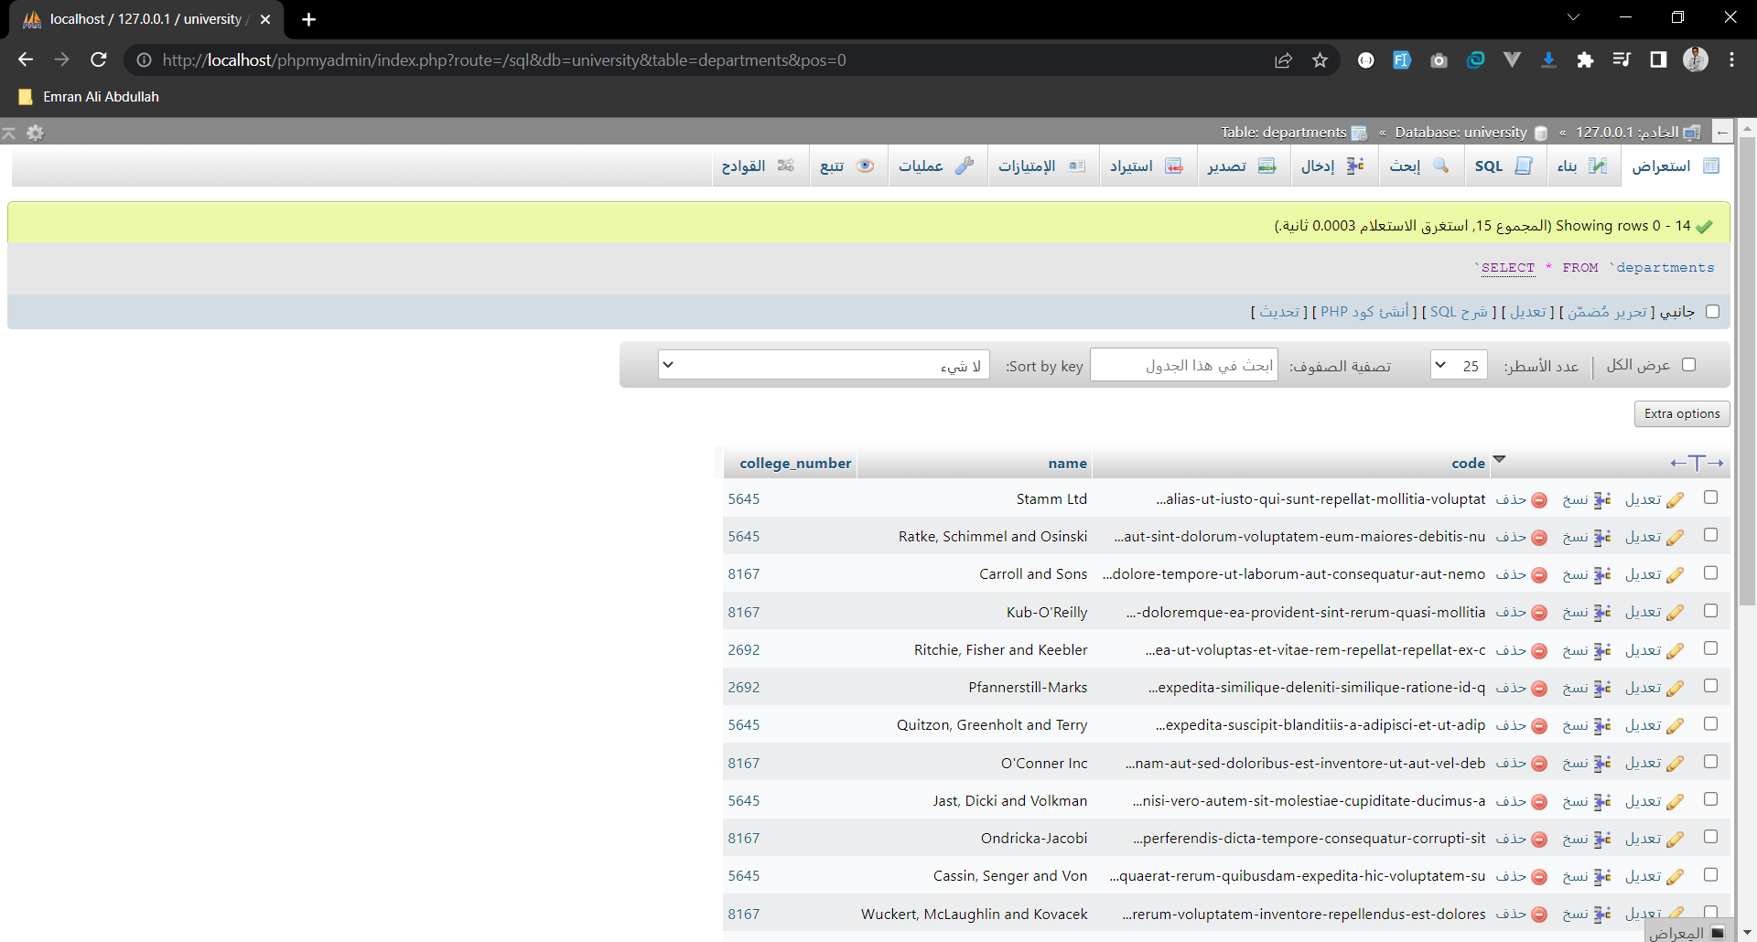

#5 Department Courses

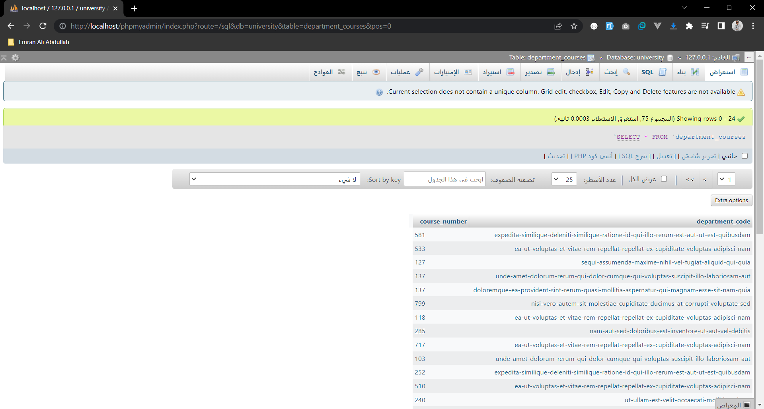

#6 Department Phones

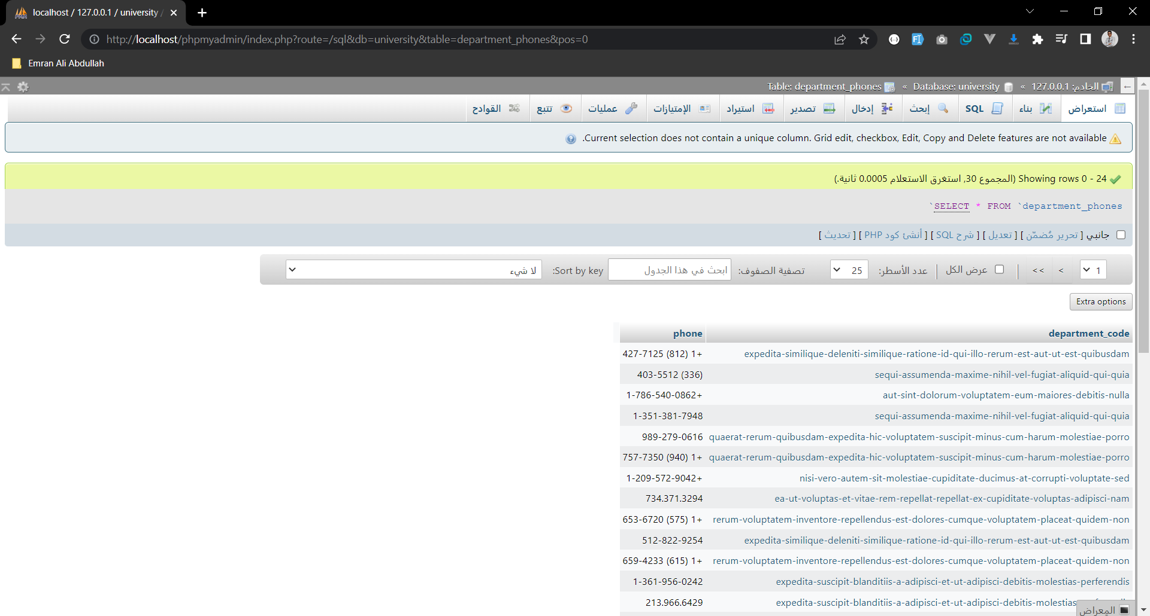

#7 Sections

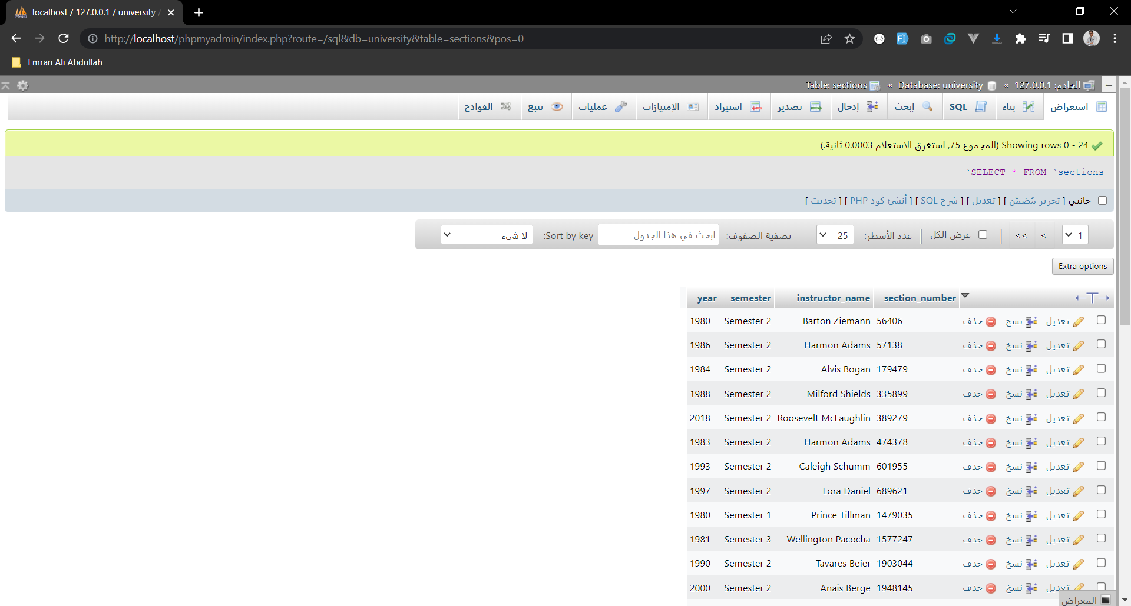

#8 Students

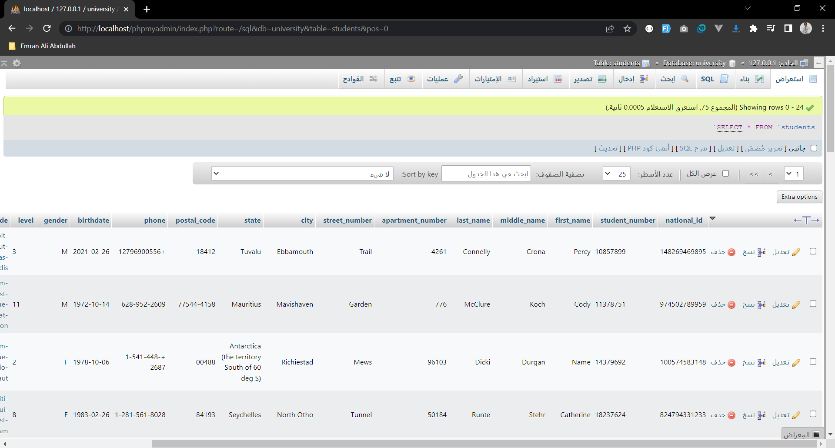

#9 Student Courses

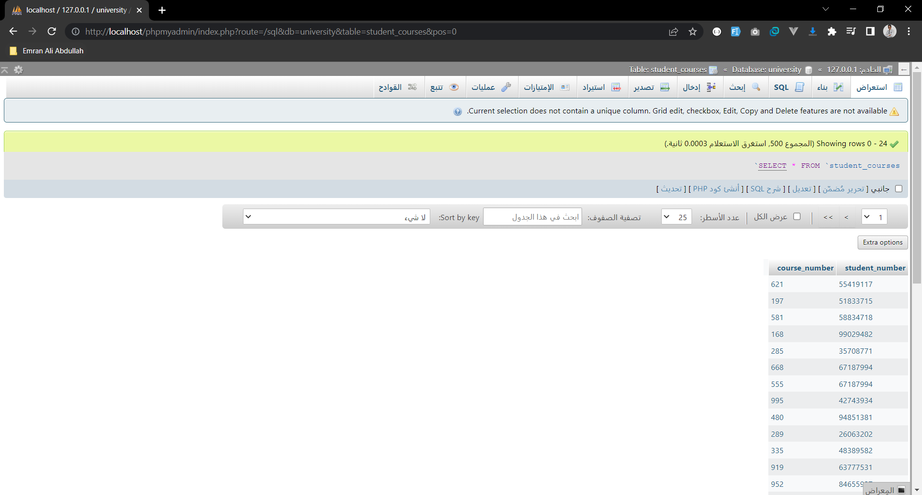

#10 Teachers

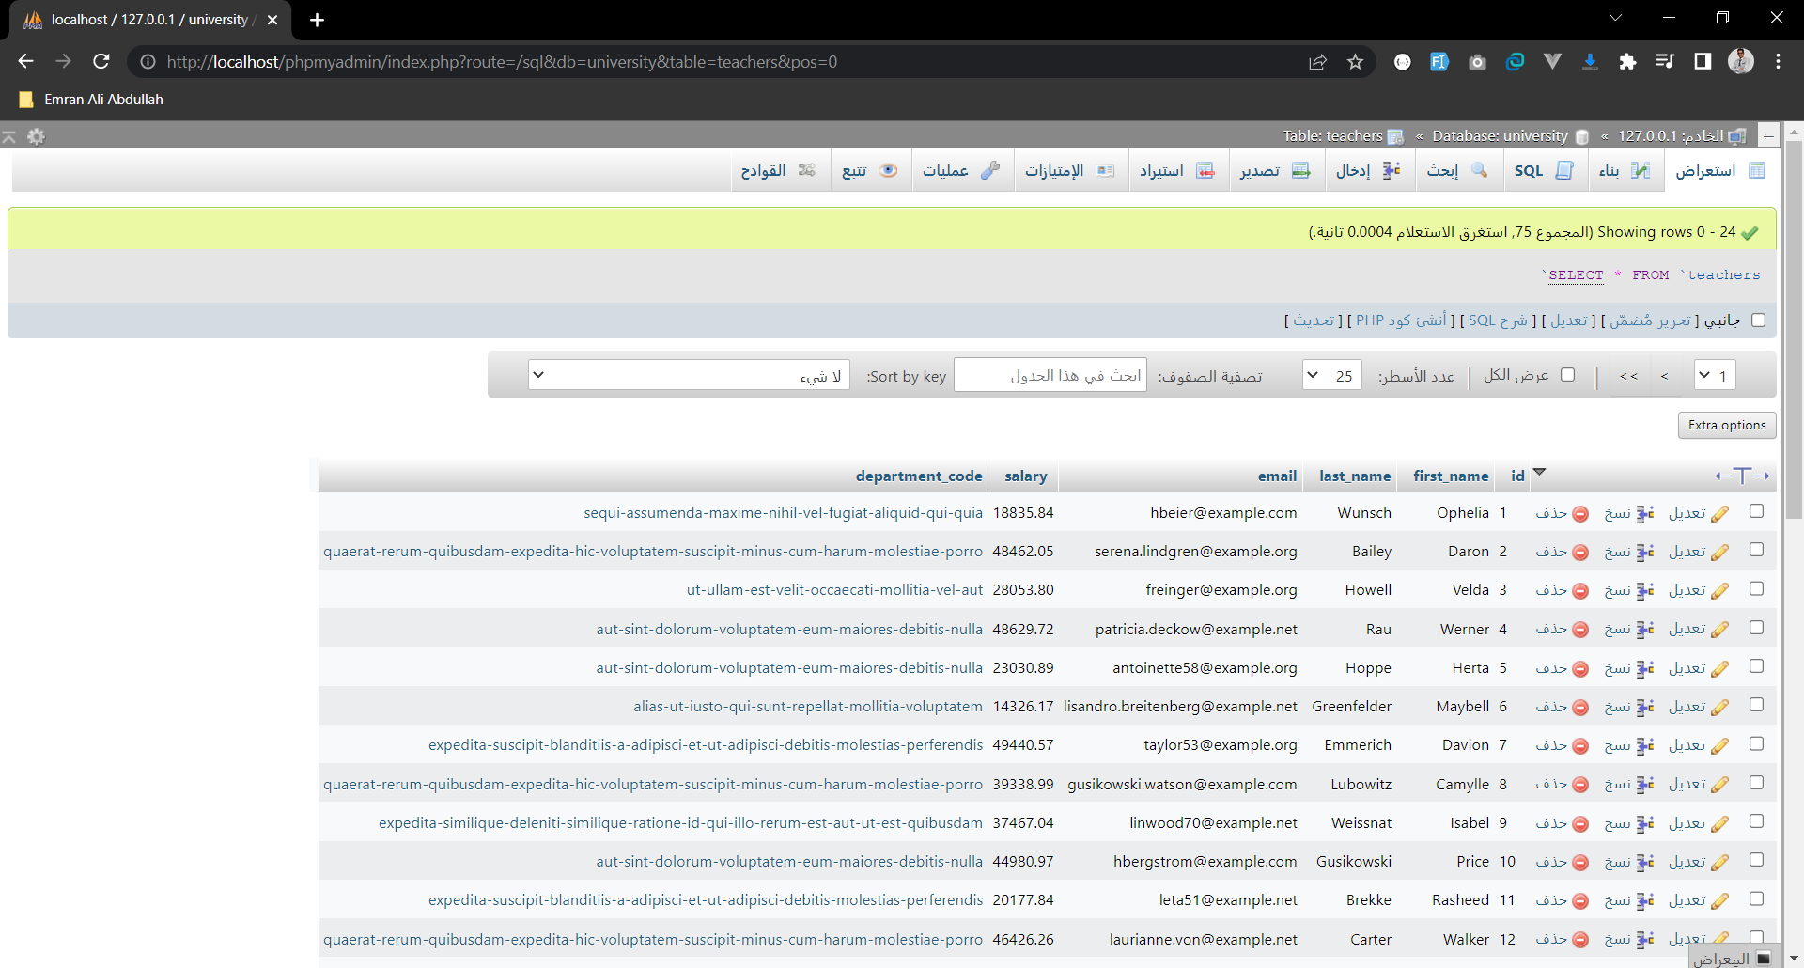

#11 Teacher Courses

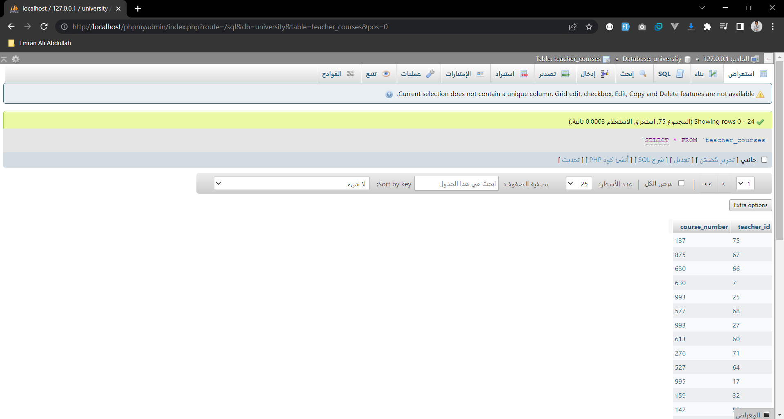

-- 1- Display all colleges college name in which the third letter of the name is 'm':

SELECT college_name FROM colleges WHERE SUBSTR(college_name, 3, 1) = 'm';

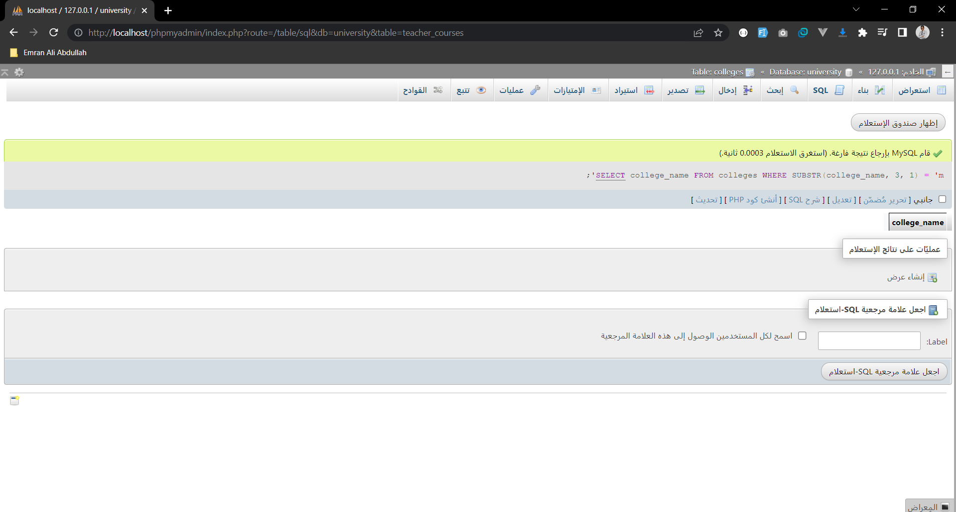

-- 2- For each colleges find college number and number of department:

SELECT colleges.college_number, COUNT(departments.college_number) as num_departments FROM colleges

LEFT JOIN departments ON colleges.college_number = departments.college_number

GROUP BY colleges.college_number;

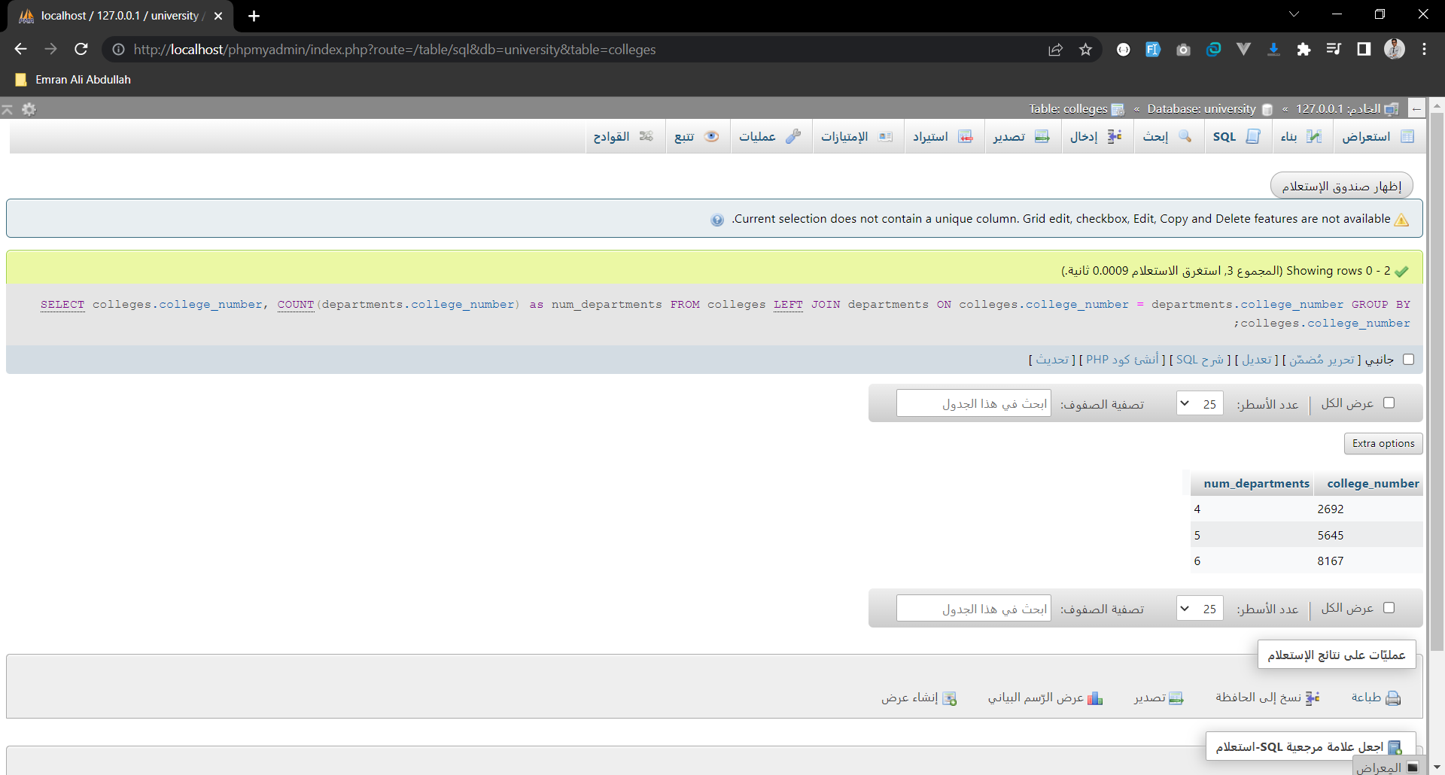

-- 3- For each department find first_name and maximum salary for all teachers when the maximum salary greater than 5000:

SELECT departments.name, teachers.first_name, MAX(teachers.salary) as max_salary FROM departments

LEFT JOIN teachers ON departments.code = teachers.department_code

GROUP BY departments.name

HAVING max_salary > 5000;

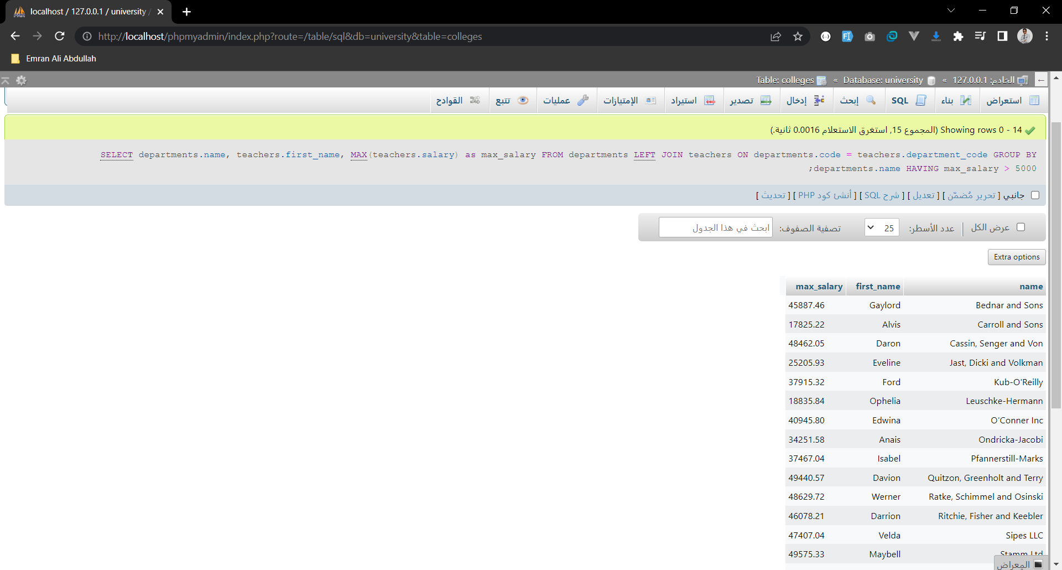

-- 4- Find the course name of courses in the art department that have credits 3:

SELECT courses.course_name FROM courses, department_courses

WHERE department_courses.course_number = courses.course_number and department_courses.department_code = (SELECT code FROM departments WHERE name = 'Art')

AND courses.credit_hours = 3;

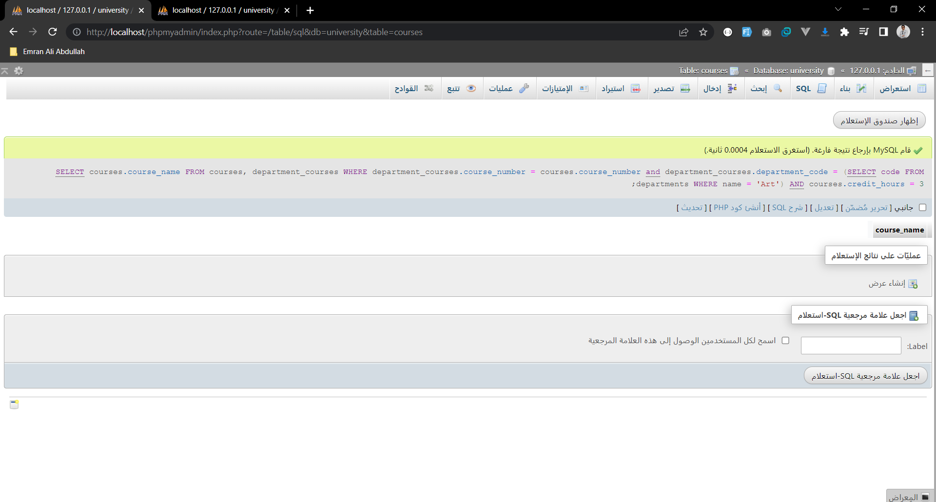

-- 5- For each course, find course name and number of student that have number of student more than 5:

SELECT courses.course_name, COUNT(student_courses.student_number) as num_students FROM courses

LEFT JOIN student_courses ON courses.course_number = student_courses.course_number

GROUP BY courses.course_name

HAVING num_students > 5;

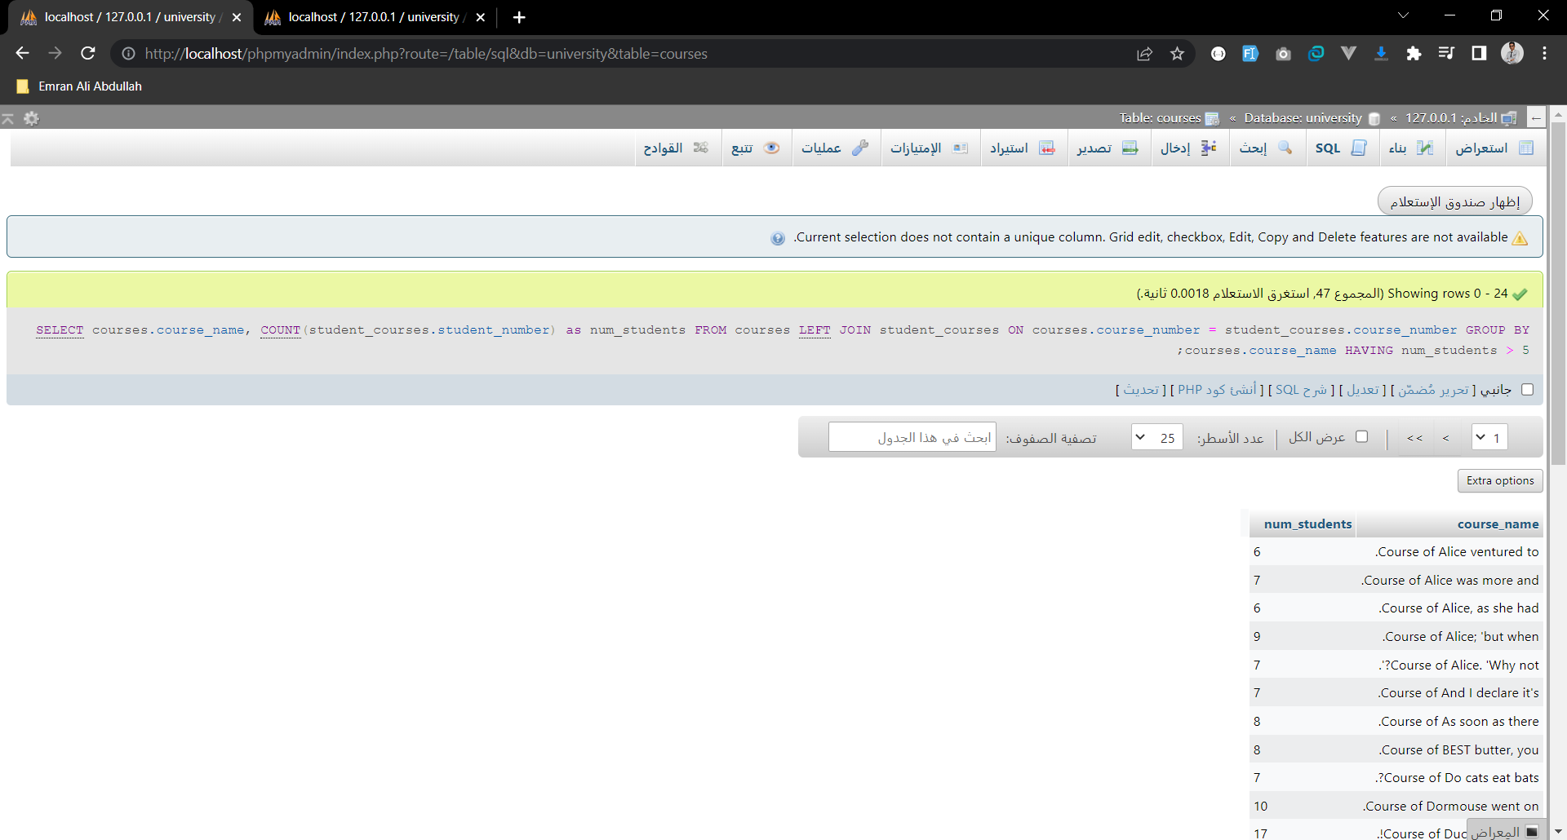

-- 6- Write a query to display the last name, department number, and department name for all teachers work in department_name NEWT WORK:

SELECT teachers.last_name, teachers.department_code, departments.name FROM teachers

LEFT JOIN departments ON teachers.department_code = departments.code

WHERE departments.name = 'Newt Work';

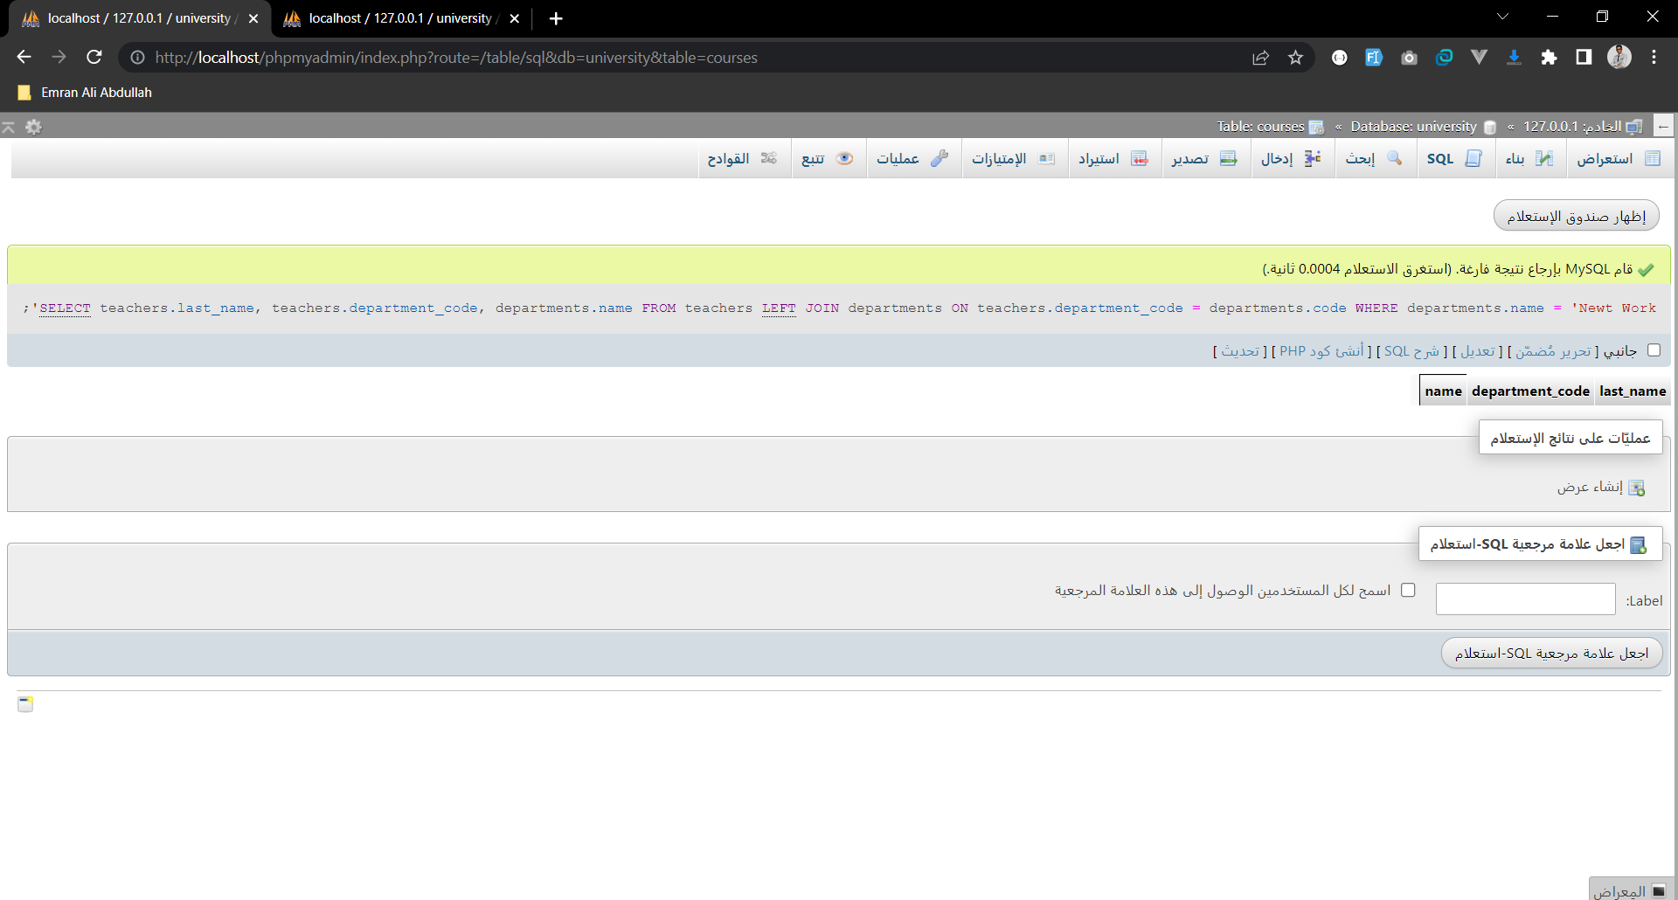

-- 7- Create query to displays the department number, last name of teacher , and email for every teacher in the IS department:

SELECT teachers.department_code, teachers.last_name, teachers.email FROM teachers

LEFT JOIN departments ON teachers.department_code = departments.code

WHERE departments.name = 'IS';

